BRIEF tries to overcome the weaknesses in space complexity of SIFT by using various compression and hashing methods, typically locality sensitive hashing methods

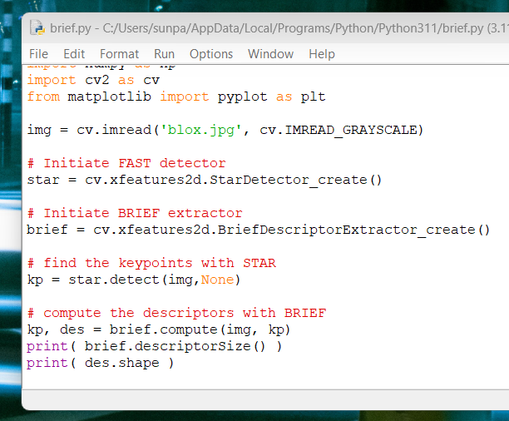

Code for using BRIEF, however it is another copyright righted algorithm, I have yet to figure out how to install and use the non free algorithms in python